Read the text Clinging Woman, p. 26 and 27

Vocabulary help (Some of the words in the text are highlighted, you should try to guess their meanings from the context in exercise Vocabulary work on page 27):

Railings-part of the fence supported by posts (metalna šipka koja služinkao dio ograde)

High-rise block-a block of tall buildings

Stunt-something done to attract attention

Descend-go down

Dummy-a copy of a human being used in movies for shooting dangerous scenes instead of real people (lutka)

Precaution-caution practised in advance to avoid danger (safety precautions-sigurnosne mjere)

Anchorage-a secure hold for something (ograda)

Tenant-occupant (stanar)

Limelight-a focus of public attention

Novelty-something new

Acute-sharp, intense

* Do exercises 2 (p.26) and 3 (p.27) as well as Vocabulary work (p.27) on your own. Then, check your answers in the answer key provided below.

Exercise 2, p.26 (Answer key)



Exercise 3, p.27 (Answer key)

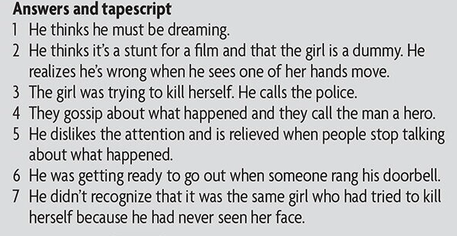

Vocabulary work, p.27



Everyday English, Showing interest and surprise, p.29

The aim of this section is to introduce and practise ways of showing interet and surprise. This includes the use of echo questions and reply questions, which need accurate stress and intonation, with a good voice range. For example, in exercise 1, p.29:



Read the transcript and do the exercise 1 (p.29)

A Jade's got a new boyfriend.

B A new boyfriend? Good for her!

A Apparently, he lives in a castle.

S Does he? How amazing!

A Yes. She met him in Slovenia.

B In Slovenia? That's interesting.

A Unfortunately, he can't speak much English.

B Can't he? I thought everyone could these days!

Read the transcript and do the exercise 3, p.29

A Sam wants to apologize.

B Does he?

A Yes. He's broken your precious Chinese vase.

B My precious Chinese vase? Oh, no!

2 A We had a terrible holiday.

B Did you?

A Yes. It rained all the time.

B ~id it?

A Yes. And the food was disgustingl

B Was it? What a drag!

3 A I'm broke.

B Are you? How come?

A Because I just had a phone bill for £500.

B £500? Why so much?

A Because I have a girlfriend in Korea.

B Do you? How interesting!

Read the transcript and do the exercise 4

4 A It took me three hours to get here.

B Did it?

A Yes. There was a traffic jam ten miles long.

B Ten miles long? That's awful!

A Now I've got a headache!

B Have you? Poor darling. I'll get you something for it.

5 A I'm on a mountain, watching the sun set.

B Are you?

A Yes. And I've got something very important to ask you.

B Have you? What is it? I can't wait!

A You'd better sit down. I'd like to marry you.

B Marry me? Wow!